SDC480 4.2 Assignment

ECPI university

Andy Kim

11/02/2025

그림 Manually clicked "API translation" buttons for remaining lines- Done and saved.

그림 In game testing 1

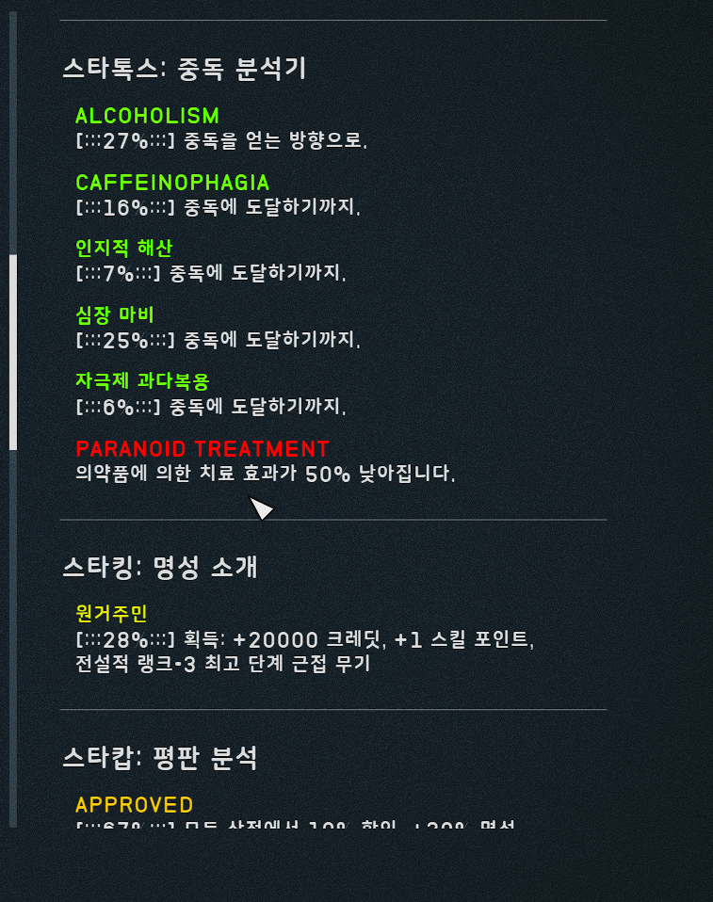

그림 In game testing 2

Next Step:

* distribute in DC inside Starfield Gallery (Korean version of Starfield Subreddit) with google drive
* Possible QC for some grave errors in Korean translation
* Possible additional translation for different mod commonly used with Starvival mod that hasn’t been translated to Korean such as Ship Vendor Framework(SVF) and compatibility plugins with Starvival mod
* Possible contact with original mod author to upload in Nexusmod as official Korean translation file.